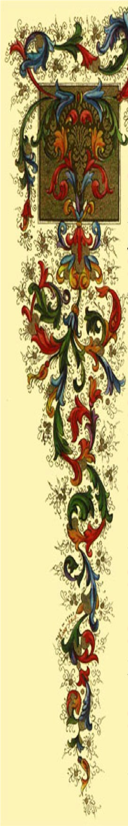

Parachutists Over
Phorty Society
“The POPS Leather Jacket”
A Symbol of Friendship and Continuity.
History, Awarding Rules
& List of Winners

“The POPS Leather Jacket”, a Symbol of Friendship and Continuity.
(text written by Bruno Imberti, Italy Top Pop)
The POPS Leather Jacket is a Symbol, highly ranking in all POP’s consideration, although it appears seldom in public exhibitions.
It might therefore be interesting to know more about its features, its origin and how it gained its fame.

The Jacket.

The Jacket is a sleeveless short coat, fitted with a single button on the chest, made by reversed sheep-skin (woolly part inside).
Since the beginning, it features a decoration on the outer back-surface, representing a large and finely painted reproduction of the POPS logo in full colours. On top of the logo the name “AUSTRALIA” is written, while under the logo the inscription “No. 898” and the Australian Flag are painted. This decoration masterpiece, as for sure it can be considered, is completed with the Author’s name and his skydiver’s identification codes (Bernie Shaw – POPS # 898 – D569) as well as by a date (31st March 1980) that allows now to establish the Jacket “official” date of coming into the POPS community, beginning a second and, as it turned out, highly ranking life.
Since then, further inscriptions were added, as every POP who had the privilege to wear the Jacket was entitled to write on it his or her name. Consequently, most of the original free space on the back side is nowadays covered, while the “invasion” of the front side has already begun.
The back part of the Jacket features also a sewn hole, or rather a cut, at the bottom left side, around which the skin clear colour is altered into brown. The hole is a reminder that the Jacket had also a “first” and adventurous life, a not-negligible part of its history.
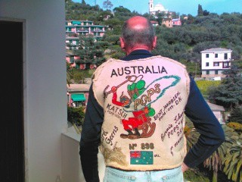
The History.
A day, long time ago, a young Bernie Shaw was peacefully spending a happy hour in a Sidney pub. Maybe that the place had not the highest rank, as suddenly he was assaulted by a Navy sailor with a knife. Luckily, the Jacket, that Bernie was wearing, gave him some protection and he thinks that it saved his life, although both of them (Bernie and the Jacket) suffered from wounds, whose signs the Jacket still bears. Since then, to Bernie the Jacket meant much more than simply a garment.
May we say that Bernie motivations were very different from vanity when, so long time ago, he decorated and signed the Jacket. That year, Bernie (ancient skydiver himself, as his D licence number witnesses) made a journey from his Australia homeland to the United States. He took the decorated Jacket along with him, as a present to be given to an eminent American skydiver as a message of friendship: his signature was the present’s dedication to the still unknown recipient.
Pat Moorehead had already a very high and deserved reputation at that time; when they met, Bernie gave the Jacket to him, chosen as symbolic representative of the American POPS.
Ten years went by until when, in year 1990, the first POPS World Meet & Championships were held in Australia. For the second time the Jacket crossed the Pacific Ocean, now accompanying Pat Moorehead.

Pat had realized how the friendship message associated with the Jacket was well suited to the spirit of the POPS Meet and he had the idea that the Jacket might become a visible sign of such message and of its continuity from Meet to Meet. As also Bernie shared these concepts, they agreed on considering the Jacket as a permanent Prize, a Symbol, to be awarded at each POPS World Meet & Championships to the participant that would best personify the POPS spirit.
Bernie’s Jacket had become “The POPS Leather Jacket”.
The Awarding Rules
Besides stating the significance of the Prize, Pat and Bernie set a few and simple rules governing its transmission. At the closing Ceremony of every POPS World Meet &
Championships, the previous recipient, after illustrating to the audience the significance of the Prize, announces the name of his or her successor, suitably selected among the POP’s participants to the Meet, and delivers to him or to her the Jacket It is duty of the previous recipient to select his or her successor. It is duty of the newly awarded recipient to preserve carefully the Jacket until the next Meet and to bring it to such Meet; it is his or her right to write his or her name on the Jacket.
After each POPS World Meet & Championships the author of this document will keep it updated with Recipient’s name and Awarding Ceremony pictures (whenever available) and will deliver a copy of it to the newly awarded Recipient, to the Top Pop of the Recipient’s Country and to the World Top Pop that will organize the subsequent Meet, for being published on the Meet Web Site.
The Recipients.
The Recipient names are written on the Jacket that, so far, is the official “document” recording them.
However, since sometimes not all details were reported along with the names, the main historical data have been completed to the outmost thanks to the helpful collaboration of many POP’s... Even so, there are still some uncertainties, and contributions to finalize the Jacket history, as well as to correct possible mistakes, will be welcome.
As said, Pat Moorehead (U.S.A.) was the first to receive the Jacket from Bernie Shaw, holding it from 1980 to 1990.
At the 1990 Meet held in Ettamoogah Pub, Albury, New South Wales (Australia) the Jacket was awarded to Lofty Thomas (U.K. Top POP No. 2).
At the 1993 Meet held in Umatilla, FL (U.S.A.) the Jacket was awarded to Bent Jakobsen (Danish POP # 019).
At the 1995 Meet held in Empuriabrava (Spain) the Jacket was awarded to “Der Katsch” (Werner Kazmirek, German POP).
At the 1997 Meet held in Aqaba (Jordan) the Jacket was awarded to Karel Geens (Belgium).
For the 1999 Meet held in Chilliwack (Canada) there is not yet knowledge of the recipient name, as the two POPs whose names appear on the Jacket and are not otherwise linked to a specific Meeting: John Crowhurst (WTP No. 3 and U.K. TP No. 5) and Michael Allum (U.K. TOP POP, WTP No. 1), say that they were never awarded of the Jacket.
At the 2002 Meet held in Matamata (New Zealand) the Jacket was awarded to Ross Stockings (Australia).
At the 2004 Meet held in Gruyère (Switzerland) the Jacket was awarded to Jim Maclean “Le Pompier” (New Zealand).
At the 2006 Meet held in Eloy, AZ (U.S.A.) the Jacket was awarded to Bruno Imberti (Italy POP # 3 and SOS # 1065).
At the 2008 Meet held in Toogoolawah, QLD (Australia) the Jacket was awarded to Alicia Moorehead (U.S.A.) who, in Jacket history, has become the first lady to receive it.
At the 2010 Meet held in Reggio Emilia (Italy) the Jacket was awarded to Volker Cornils (Germany). Top POP Deutschland.
At the 2012 Meet held in Teuge (Holland) the Jacket was awarded to Marjolaine de Pury (France). Founder of the France POPS in 1993, the second lady receiving the Jacket.
At the 2014 Meet held in San Juan (Argentina) the Jacket was awarded to Buzz Bennet, (Canada), World Top POP #9
At the 2016 Meet held in Eisenach (Germany) the Jacket was awarded to Peter Schmid, (Switzerland), Top POP Swiss.
At the 2018 Meet held in Nagambie (Australia) the Jacked was awarded to Sergey Kiselev, (Russia), ex Top POP Russia
It seems that at the Toogoolawah Meet a record was set thanks to the contemporary presence of Bernie Shaw and six Jacket previous and newly awarded recipients, all together covering a period of 28 years in Jacket History.
All of them appear in the picture, taken at the Awarding Ceremony on May 3, 2008.
It is everybody’s wish that this record be improved more and more in the future Meets.

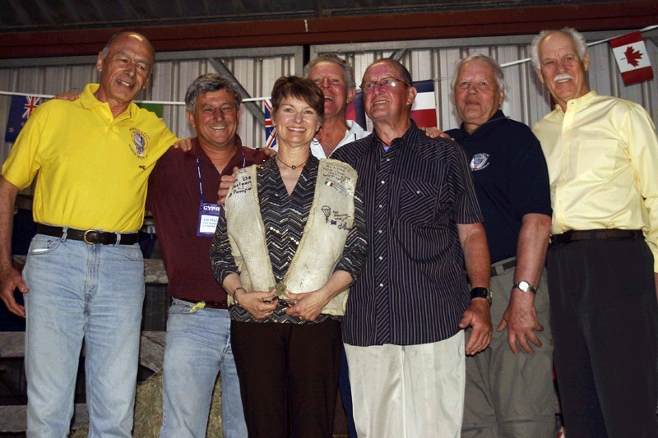
Toogoolawah, May 3, 2008; (from left to right):
Bruno Imberti (Eloy, 2006); Jim Maclean (Gruyère, 2004); Alicia Moorehead (Toogoolawa, 2008); Ross Stockings (Matamata, 2002); Bernie Shaw (original owner of the Jacket); Bent Jakobsen (Umatilla 1993); Pat Moorehead (who received the Jacket from Bernie Shaw in 1980).
The record was equalled twice at Teuge Meet, where seven previous and current Jacket holders were present in different days:
- on July 7, 2012, the day before the Closing Ceremony, seven previous and current holders had the chance to meet at the D.Z.: Pat Moorehead (who received the Jacket
from Bernie Shaw in 1980); Bent Jakobsen (Umatilla 1993); Werner Kazmirek (Empuriabrava 1995); Ross Stockings (Matamata, 2002); Bruno Imberti (Eloy, 2006); Alicia Moorehead (Toogoolawa, 2008); Volker Cornils (Reggio Emilia 2010).
- on July 8, 2012, at the closing Ceremony, as appearing in the picture taken there:
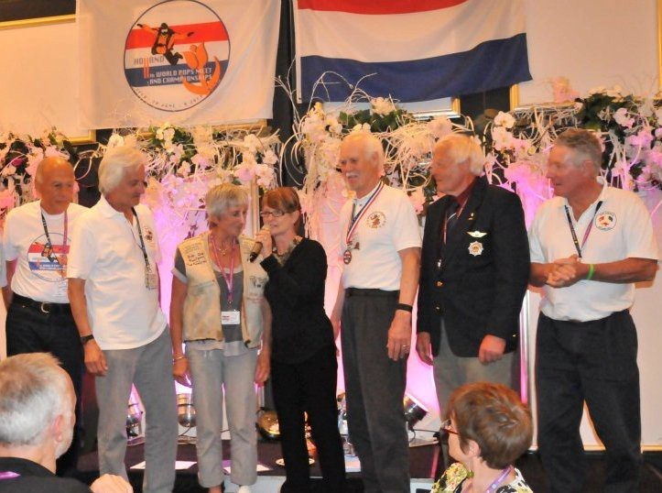
Teuge, July 8, 2012; (from left to right):
Bruno Imberti (Eloy, 2006); Volker Cornils (Reggio Emilia 2010); Marjolaine de Pury (Teuge 2012); Alicia Moorehead (Toogoolawa, 2008); Pat Moorehead (who received the Jacket from Bernie Shaw in 1980); Bent Jakobsen (Umatilla 1993); Ross Stockings (Matamata, 2002).

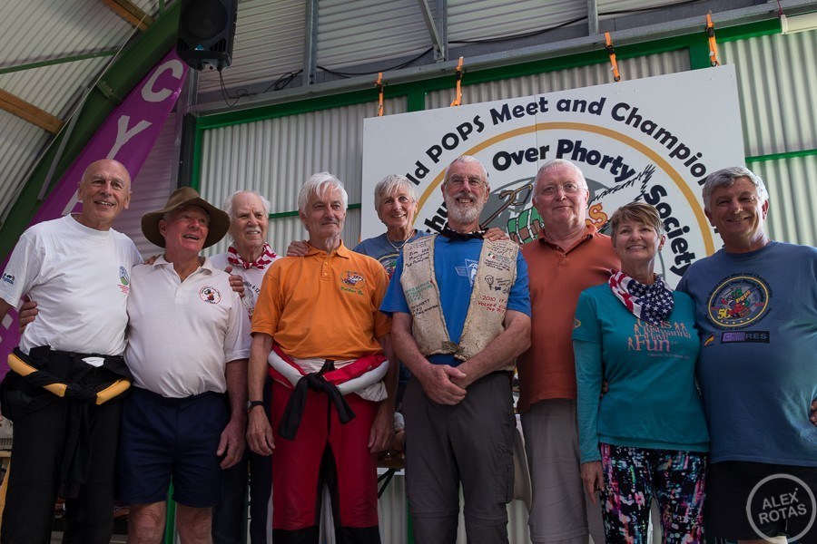
2016, Eisenach Germany Jacket Holder from 2014: Buzz Bennet with from left to right: Bruno Imberti, Ross Stockings, Pat Moorehead, Volker Cornils, Marjolaine de Pury, Werner Kazmirek, Alicia Moorehead and Jim Maclean.
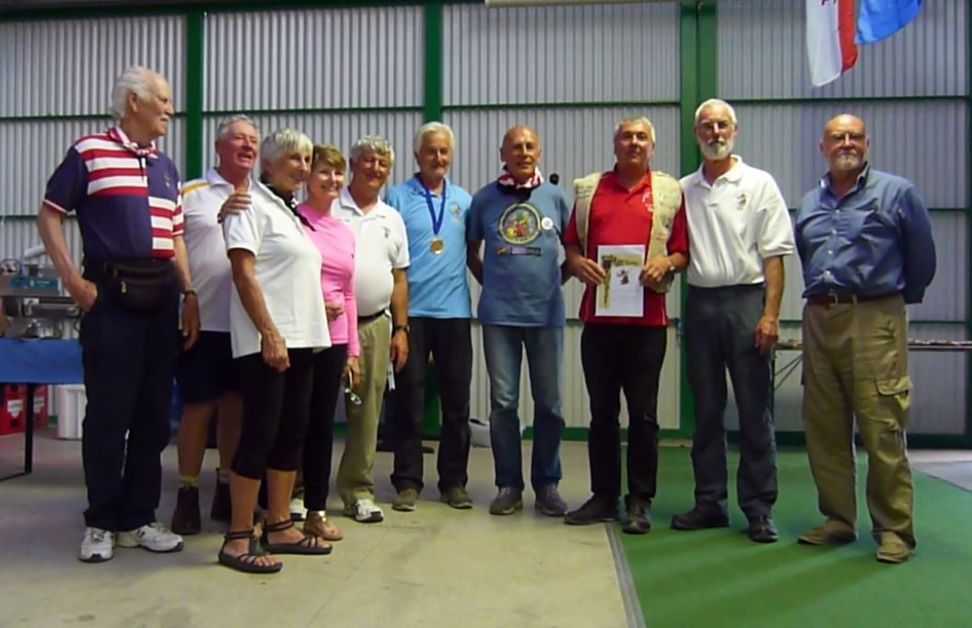
Eisenach Germany, August 13, 2016
Jacked holder Peter Schmid, (Swiss) with from left to right:
Pat Moorehead, Ross Stockings, Marjolaine de Pury, Alicia Moorehead, Jim Maclean, Volker Cornils, Bruno Imberti, Peter Schmid, Buzz Bennet and Michael Allum (1999 Canada, never awarded the Jacket)
In Germany where eleven previous and current Jacket holders present.
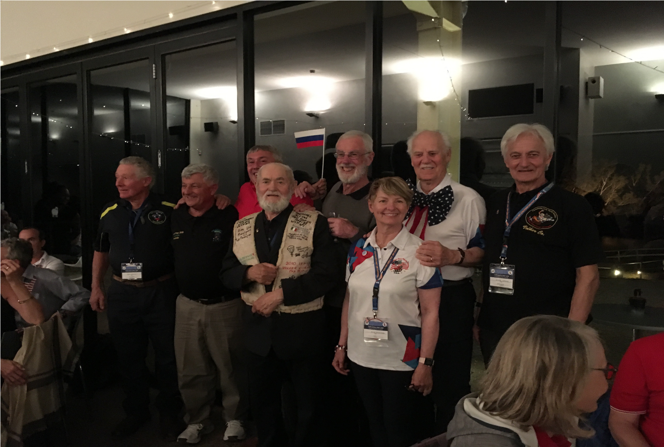
Nagambie Australia, April 28, 2018
Jacked holder Alexey Kiselev (Russia) with from left to right:
Ross Stockings, Jim Maclean, Peter Schmid, Sergey Kiselev, Buzz Bennet, Alicia Moorehead, Pat Moorehead and Volker Cornils.
Acknowledgments
The author of these notes is grateful to the many eminent POP’s that, digging in their memories and archives, have made it possible to put together the information upon which, along with the inscriptions on the proper Jacket, this document is based.
Mentioning them in alphabetical order, they are: Michael Allum, Dick Barton,
Jeff Chandler, John Crowhurst, Karel and Steven Geens, Bent Jakobsen, Werner Kazmirek, Pat Moorehead, Karl Poruben, Bernie Shaw, Ross Stockings, Bill Wood, Tom Zukowski.

POPS Leather Jacket Amendment Record
Original issue: May 21, 2008
Bruno Imberti bruno.imberti@libero.it
Buzz Bennett buzzraf@telus.net
Volker Cornils
VolkerCornils2016@pop-d.de
Updated in 2018 by WTP#10

