The Spirit of Pops 2018

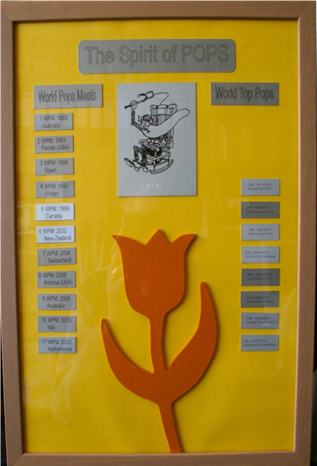
What is “The Spirit of Pops”?
The “Spirit of Pops” is a picture frame showing
on the left side all the years and countries where
the “World Pops Meet” was organized.
So, it shows on little cards:

World Pops Meets
1: WPM 1989: Australia
2: WPM 1993: USA – Florida
3: WPM 1995: Spain
4: WPM 1997: Jordan
5: WPM 1999: Canada
6: WPM 2002: New Zealand
7: WPM 2004: Switzerland
8: WPM 2006: USA – Arizona
9: WPM 2008: Australia
10: WPM 2010: Italy
11: WPM 2012: Netherlands
12: WPM 2014: Argentina
13: WPM 2016: Germany
14: WPM 2018: Australia
15: WPM 2020: United Kingdom

On the right side are all “World Top Pops” mentioned: the time period and their names.
So, it shows on little cards:
WTP#1: 1995-1997: Michael Allum
WTP#2: 1997-1999: Alicia Moorehead
WTP#3: 1999-2002: John Crowhurst
WTP#4: 2002-2004: Theo Fritschy
WTP#5: 2004-2006: Karl Poroben
WTP#6: 2006-2008: Ian Robertson
WTP#7: 2008-2010: Lamberto Serenelli
WTP#8: 2010-2012: Ronald van Rijn
WTP#9: 2012-2014: Buzz Bennett
WTP#10: 2014-2016: Volker Cornils
WTP#11: 2016-2018: Gary Zuiderwyck
WTP#12: 2018-2022: Polly Chandler

Why this “Spirit of Pops”?
In the organisation of the “World Pops Meet and Championships” there are several awards:
- the leather jacket
- the silver plate
- the pops crystal plate
But.....there is nothing for the person who is responsible for the total organisation of any “World Pops Meet and Championships”, the World Top Pop.

So, hereby I (Ronald van Rijn, WTP #8) introduce the “Spirit of Pops” award for the World Top Pop who is responsible for the organisation of the “World Pops Meet and Championships”.
Note.
The intention was to give this award to the new “World Top Pop” during the “11th World Pops Meet” in Teuge. I showed this award in the Top-Pop meeting on the 6th of July 2012. But, in this meeting there was no new World Top Pop chosen. So, I took this award with me to my house.
But now there is a new World Top Pop: Buzz Bennett followed by Volker Cornils, to whom the award was given at the end of WPM 12.
The purpose of this award.
During all the days of the World Pops Meet and Championships, this award must clearly be hung in a room (hangar) where all participants can see this award.
So, all participants can in this way see the history of the “World Pops Meets” on this award. During the Top-Pop meeting there will be chosen (mostly) a new country and a new World Top Pop.
The new chosen World Top Pop will receive this award during the prize-giving ceremony in the presence of all participants on the last day of the World Pops Meet.
The departing World Top Pop will hand over this award to the new World Top Pop.
New cards.
The new chosen World Top Pop is responsible for new little cards on the “Spirit of Pops” award. He/she must let make new cards in the same size as shown on the award.
In the period after receiving this award and the start of the new World Pops Meet, this award can be given a place on the desk, or in the house of the new World Top Pop, or on the airfield where the new World Pops Meet will be held.
Resume.
At the end of any “World Pops Meet and Championships” there are now four awards to hand over:
- the leather jacket
- the silver plate
- the pops crystal plate
- the “Spirit of Pops” award
Ronald van Rijn
World Top Pop #8
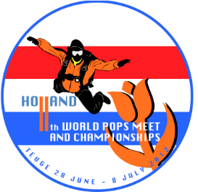

.
Spirit of POPS Award Amendment Record

Updated by Volker Cornils, WTP#10

